Student Group Self Enrolment Instructions

Students are required to “self-enrol” into their assessment groups. You can only be a member of one group at a time.

It is recommended you do not join a group without first reaching agreement between all group members.

**Instructions**

* Once group members are confirmed, log into your unit on Moodle. Find the “Self Enroll” icon in the Assessment Block as shown below and click on it.

* Choose a group from the options available to you by click in “Become member of”. If you are the first, then choose a group number. You will be able to see the names of existing participants.

* You will then view a box asking for confirmation as shown below. You have the option to confirm or cancel.

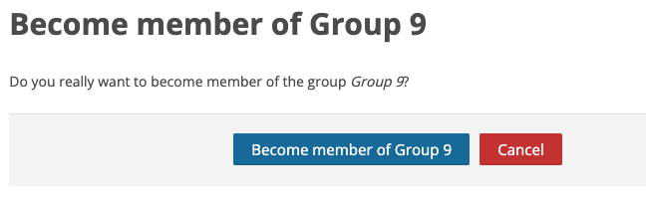

* Should you wish to leave or joined the group in error, you simply select the “Leave Group” option.

* Once the group has reached the maximum number of participants, you will no longer have the option to join the group and will need to select a different group to join.
* If you need to change groups, first, leave the group you are in, then repeat the steps above to join a new group.